**Regression Assignment**

**1.Problem Statement:**

The problem is to predict the insurance charges as an output based on the input given in the dataset by the client. The problem statement deals with number and we have to select ‘Machine Learning’ Domain. So, in the dataset the input and output is clear hence it will come’s under ‘Supervised Learning’. With the help of Ai algorithms(MLR,SVM,DT,RF) we are going to create a best model.

**2.Basic info of Dataset:**

Total number of Rows and Columns- 1338 Rows x 5 Columns

**3.Pre-processing:**  
 Converting the String Columns named ‘Sex’ and ‘Smoker’ to Numerical data with the help of ‘get dummies’ algorithm.

**4.R_Score Values:**

1.Multiple Linear Regression- R_Score value: 0.78

2.Support Vector Machine Regression:

|  |  |  |
| --- | --- | --- |
| SL NO | KERNEL | R SCORE |
| 1 | linear | -0.11 |
| 2 | rbf | -0.08 |
| 3 | poly | -0.06 |
| 4 | sigmoid | -0.08 |
| 5 | precomputed | Invalid |

**Default**

**Table: For SVM linear gives the better R score value.**

3.Decision Tree Regression:

|  |  |  |  |
| --- | --- | --- | --- |
| SL NO | CRITERION | SPLITTER | R VALUE |
| 1 | squared_error | best | 0.65 |
| 2 | friedman_mse | best | 0.64 |
| 3 | absolute_error | best | 0.69 |
| 4 | poisson | best | 0.67 |
| 5 | squared_error | random | 0.76 |
| 6 | friedman_mse | random | 0.74 |
| 7 | absolute_error | random | 0.71 |
| 8 | poisson | random | 0.71 |

**Default**

**Table: For Decision Tree Squared error gives better R Score.**

4.Random Forest Regression:

|  |  |  |  |
| --- | --- | --- | --- |
| SL NO | Criterion | Random state | R Value |
| 1 | Squared_error | 0 | 0.85 |
| 2 | Absolute_error | 0 | 0.85 |
| 3 | Friedman_mse | 0 | 0.85 |
| 4 | poisson | 0 | 0.85 |

**Table: For Random Forest Every algorithm gives same score**

**Hence the Random Forest of every algorithm giving the best R Score value, The best model to deploy is Random forest Regression with the R score value of 0.85**

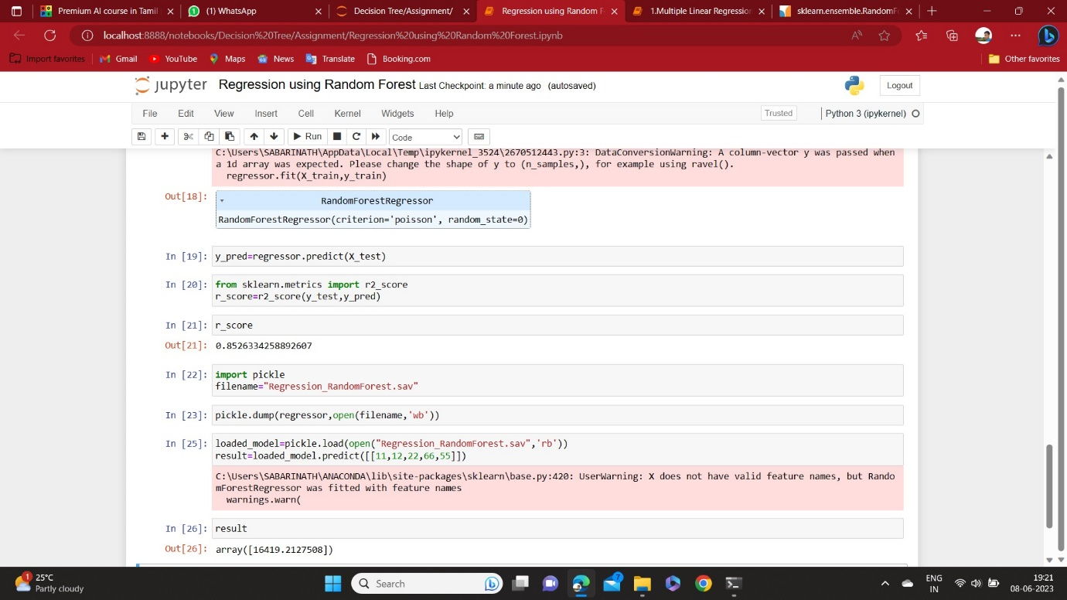

**Print screen of the best R score value.**